EASI-STRESS
EUROPEAN ACTIVITY FOR STANDARDISATION OF INDUSTRIAL RESIDUAL STRESS CHARACTERISATION
H2020 NMBP-35-2020
Grant Agreement Number: 953219

Deliverable Report:
D7.4 Report on outreach activities

Project Deliverable Information Sheet
EASI-STRESS Project | Project Ref. No. 953219
 | Project Title: EASI-STRESS - European Activity for Standardisation of Industrial residual STRESS characterisation
 | Project Website: www.easi-stress.eu
 | Deliverable No.: D7.4 Report on outreach activities
 | Deliverable Type: Report
 | Dissemination Level: Public | Contractual Delivery Date:  30/06/2021
Actual Delivery Date:
02.07.2021
 | EC Project Officer: Yanaris Ortega Garcia

Document Control Sheet
Document | Title: D7.4 Report on outreach activities
 | Version: 1.0
 | Available at:
 | Files:
Authorship | Written by | Marc Thiry
 | Contributors
 | Reviewed by
 | Approved

Table of Contents

Project Deliverable Information Sheet 2
Document Control Sheet 2
Table of Contents 3
1. The EASI-STRESS Project 4
2. Internet based Communication and Dissemination activities 5
1. Tools and Channels 5
3. Physical and online events: 5

The EASI-STRESS Project

EASI-STRESS (European Activity for Standardisation of Industrial residual STRESS characterisation)
The EASI-STRESS project has the overall aim to strengthen industrial access and uptake of non-destructive synchrotron x-ray and neutron diffraction-based residual stress characterization tools by validation against accepted destructive techniques and development of protocols, in close collaboration with industry. This will enable a better understanding of the formation and progression of residual stresses by direct comparison with and incorporation of the measured data into modelling tools. Incorporating this knowledge into the design process and lifetime assessment of metallic components will give more reliable products with increased lifetime and reduced material usage. Currently, conservative worst-case-scenario safety factors, e.g. as defined by EUROCODE, are used when designing metallic components exposed to cyclic loads. In knowing the actual internal stress levels, the safety factors can be reduced, resulting in an estimated material cost saving of around 15 %. The total value of metallic structures across the industrial sectors represented by the partners is estimated as having a production value of more than EUR 100 billion per year. Other industrial benefits include increased lifetime and reduced time-to-market.

Expected Project Key Outputs
- To develop synchrotron x-ray and neutron diffraction-based residual stress characterization tools for industrial use
- To strengthen European industrial uptake of the characterization tools through open access to data and protocols, development of a test bed service and collaboration/synergy/standardization activities
- To develop European-wide characterization standards, protocols and data exchange procedures to facilitate the industrial use of the characterization tools, e.g. through traceability and comparability
- To secure a competitive advantage across European industrial sectors through optimised component design, reduced materials use through reduced safety factors (material savings of around 15%) and an estimated cost-reduction of 5% in a EUR 350 billion market through shortened time-to-market, and increased lifetime
The purpose of all communication efforts is to support the achievement of the project outputs.

Internet based Communication and Dissemination activities

Website

The project’s website, www.easi-stress.eu, went online in June 2021.
Upcoming events with EASI-STRESS participation and other news will be published regularly.
More details about thee website can be found in deliverable D.7.1..

Twitter

News about the project and other interesting developments in the field of (neutron and synchrotron based) residual stress Analysis are distributed via Twitter by the account @EASI-STRESS.
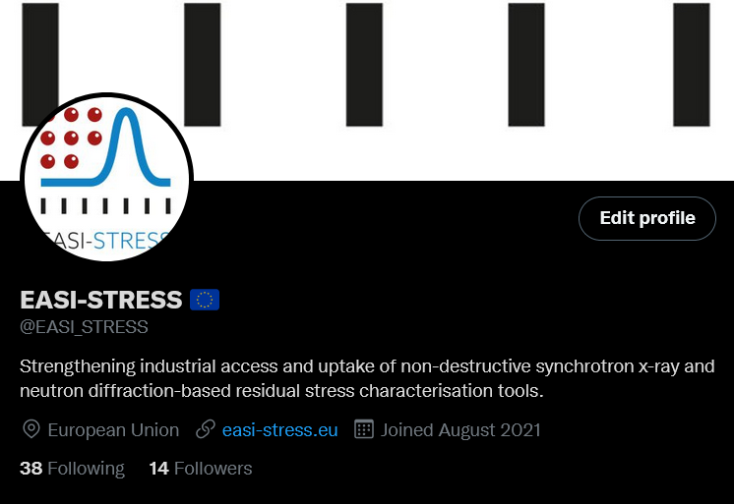
The European Commission’s CORDIS portal was informed about the Twitter account and the Twitter feed added to the CORDIS landing page.
Statistics:
Tweets: 18
Followers: 14
Impressions: 3,300

LinkedIn Showcase

Via LinkedIn, EASI-STRESS disseminates information via a “showcase” page.
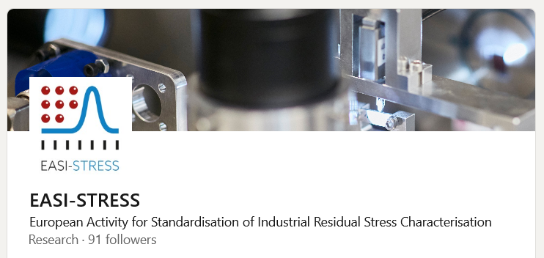
https://www.linkedin.com/showcase/easi-stress/
Statistics:
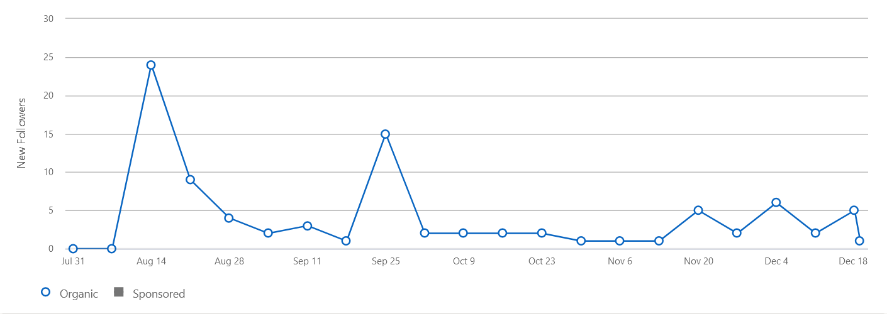
Followers total: 91
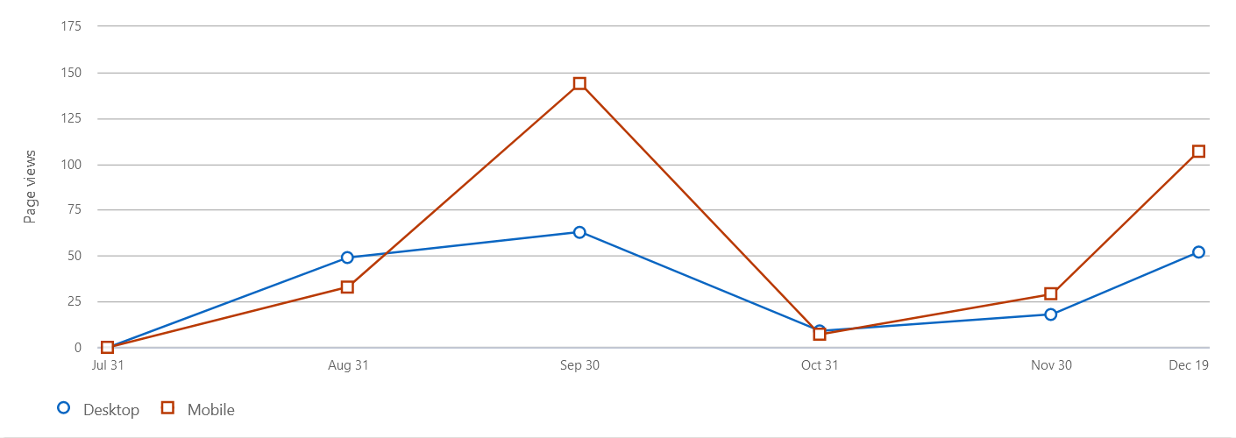
Total page views: 378
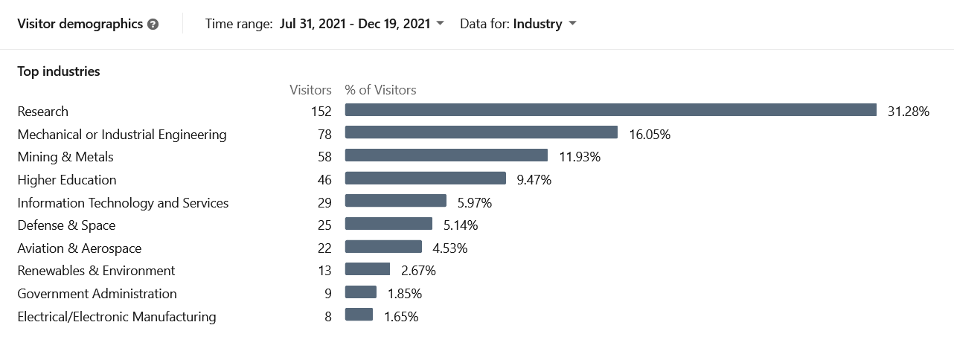
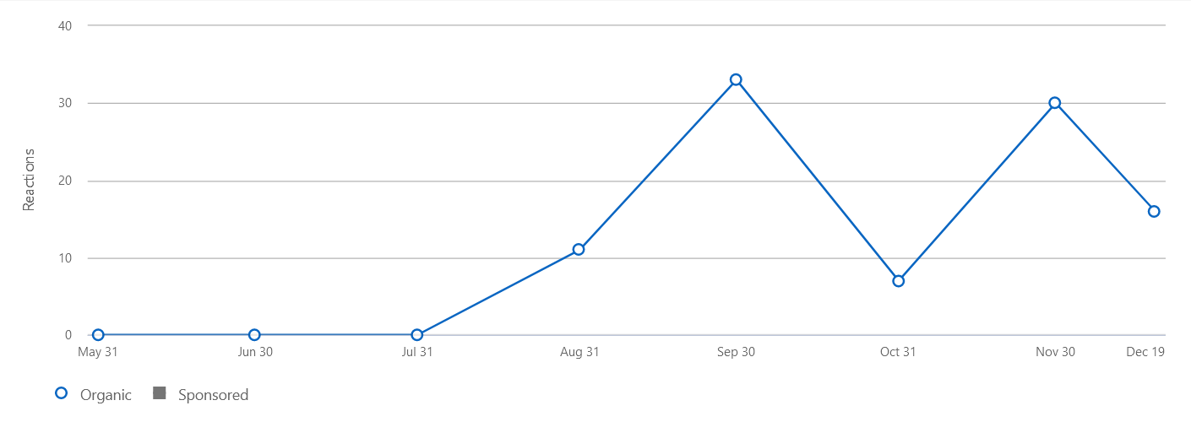
Total reactions: 97

News Article/Press release

In November 2021, a news article about the status of EASI-STRESS was composed and made available to the project partners with the proposal to have their PR or communication departments make use of it to disseminate information about EASI-STRESS via their communication channels.
The original article can be found in the annex.
The following partners modified the template to their needs and published it on their website and/or LinkedIn respectively Twitter accounts:
Partner | Homepage | Twitter | LinkedIn
Nemak | Link | x | x
University of Manchester | Link | x | x
ILL | Link
OHB | pending | x | x
Centre for Energy Research | Link |  | x
Hereon | Link | x | x

Physical and online events:

EASI-STRESS partners participated in the following events and communicated ideas, goals and first results:

Title | Place | date/time | Contribution/Partner
CEN TC138 meeting | Online | 08/10/2020 | Presentation, Nikolaj Zangenberg, DTI
CEN/OYSTER (EMCC and CHADA meeting) | Online | 18/02/2021 | Caroline Boudou, ILL; Ennio Tito Capria, ESRF
Meeting in DK S239 standardisation group | Online | 10/03/2021 | Presentation, Nikolaj Zangenberg, DTI
ACCELERATE Research2Business Online Workhop: Residual Stress Analysis | Online | 09/03/2021 | Presentation, Nikolaj Zangenberg, DTI
Meeting with FormPlanet | Online | 12/03/2021 | Nikolaj Zangenberg, DTI; Matthew Roy, U-Man; Fabien Lefebvre, CETIM; Ennio Tito Capria, ESRF
Meeting with EMCC & NMBP-35 projects | Online |  | Nikolaj Zangenberg, DTI; Ennio Tito Capria, ESRF
Danish Welding and NDT association seminar | Kolding, DK | 31/08/2021 | Presentation, Nikolaj Zangenberg, DTI
SF2M | Online (Paris) | 10/03/2021 | EASI-STRESS mentioned in slides
Workshop Additive-Manufacturing | Online (Grenoble) | 01/06/2021 | EASI-STRESS mentioned in 3 presentations
Les Assises Européennes de la Fabrication Additive 2021 | Online | 06/08/2021
Central European Training School on Neutron Scattering | Budapesz (HU) | 04/10/2021 | Lecture, Thilo Pierling, ILL
TechConnect Europe | Malmö (SE) | 15/11/2021 | Presentation (Nikolaj Zangenberg, DTI; Marc Thiry, Hereon)
Fatigue Design 2021 | Senlis (FR) | 17/11/2021 | Flyer at CETIM Booth
Rendez-vous Carnot | Lyon (FR) | 17/11/2021 | ILL, B2B Meetings
CEN/TC 138 Plenary November 2021 |  | 11/2021 | Dansk Standard
MECASENS 2021 | Prague, CZ | 25/11/2021 | Presentations

Annex I: Press release

Standardisation of industrial residual stress characterisation: EASI-STRESS
Since the beginning of 2021, [organisation/company] has been engaged in the EU-project EASI-STRESS with partners from industry, academia and research and technology organisations. The project is now picking up speed: After months of preparation, the scientists now examine the first samples at Institut Laue-Langevin and European Synchrotron Radiation Facility ESRF (both Grenoble), at instruments of Helmholtz-Zentrum Hereon at DESY (Hamburg) and at Budapest Neutron Center BNC (Budapest).
There have always been various ways of working metals. For example, they can be forged, welded, cast or additively manufactured. In all these processes, residual stresses are generated in the material. But: Residual stresses in metals may lead to catastrophic failures under fatigue processes. Therefore, they are of key importance across all industrial sectors where metals are used, e.g. within the transportation and energy sectors. Such residual stresses are investigated using various methods. These include neutrons and synchrotron X-rays. They penetrate into metals and alloys and enable non-destructive direct determination of bulk stresses.
Insufficient comparability
In the past, industrial developers have struggled to utilise synchrotron x-ray and neutron diffraction-based residual stress characterisation tools due to insufficient data comparability and lack of harmonised protocols. This made it difficult to confirm reproducibility and traceability of the measurements. “We aim at lowering these barriers for industry by setting up European-wide standards and operating procedures and harmonising data formats,” explains project coordinator Dr. Nikolaj Zangenberg.
The EASI-STRESS project wants to support companies in analysing and improving their materials in the best possible way. With the help of the measurements, the industry can better predict and control stresses in materials and thus optimize the design of components. It is also sustainable: those who know their materials well can reduce material consumption or shorten time to market by qualifying new materials or processes more quickly.

During November, the project partners will conduct experiments from performed residual stress measurements on new developed round robin samples. The samples are measured at several neutron and synchrotron instruments, relevant standardised laboratory techniques. The results will be compared to modelling data. The samples are designed to replicate different industrial processed that will, at a later stage in the project, also be investigated in real industrial components through case studies defined by the industrial partners.

The goals of EASI-STRESS are:
• improving synchrotron x-ray and neutron diffraction-based residual stress characterisation tools for the needs of industrial use
• developing European-wide characterisation standards, protocols and data exchange procedures to facilitate the industrial use of the characterisation tools, e.g. through traceability and comparability
• strengthening European industrial uptake of the characterisation tools through open access to data and protocols, development of a test bed service and collaboration/synergy/standardization activities
• to secure a competitive advantage across European industrial sectors through optimised component design, reduced material use through reduced safety factors (material savings of around 15%) and an estimated cost-reduction of 5% in a EUR 350 billion market through shortened time-to-market, and increased lifetime

The EASI-STRESS consortium consists of the following partners:

Research Infrastructures: Institut Laue-Langevin (FR, GER, UK), European Synchrotron Radiation Facility (FR), Helmholtz-Zentrum Hereon (GER), Centre for Energy Research (HU)
Universities and Research and Technology Organisations: Danish Technological Institute (DK), University of Manchester (UK), CETIM (FR),
Industry: Siemens Gamesa (DK), Rolls Royce PLC (UK), OHB Systems AG (GER), Volume-e (FR), Arcelor Mittal (ESP), Nemak (AU), EDF (FR),
Standardisation body: Dansk Standard (DK)

More information at: www.easi-stress.eu
Follow us on
Twitter: @EASI_STRESS
LinkedIn: https://www.linkedin.com/showcase/75054908

Contact:
Project coordinator
Dr. Nikolaj Zangenberg
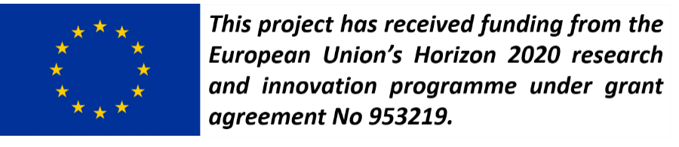
Director Materials
Danish Technological Institute
nzg@teknologisk.dk

Communication officer
Dr. Marc Thiry
Helmholtz-Zentrum Hereon
marc.thiry@hereon.de

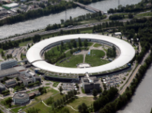
The electron storage ring of the ESRF in Grenoble, one of the most powerful synchrotrons in Europe.
©ESRF.

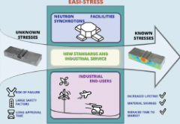
In the EU project EASI-STRESS, characterizations of residual stress of materials are to be standardized and optimized.
© DTI

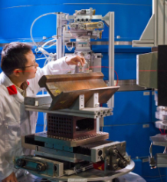
A Hereon scientist examines samples at FRM II, the research neutron source at the Heinz Maier-Leibnitz Center.
© Andreas Heddergott / TU München

